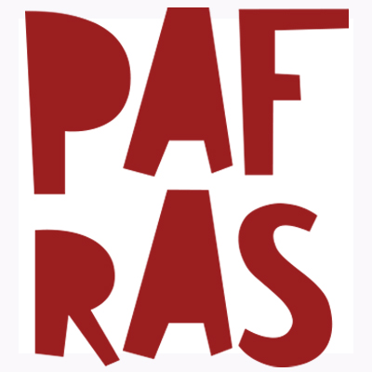 | Young Migrants Matter Referral Form

Before you refer, does the young person:
- Have an insecure immigration? (e.g. been refused asylum; is undocumented; visa over-stayer)
- NOT an EEA or EU citizen?
- Aged 16-24 years old and living in Leeds?
- Given consent to share their information with PAFRAS?

YOUNG PERSON’S DETAILS

Name:
family name in CAPITALS
Address:
or c/o address
Contact number:
Date of birth:
Assessed/assigned date of birth (If age disputed)

Immigration status: |  | Support status:
Approx date of arrival in the UK:

Nationality & Country of origin: |  | Languages spoken: (including dialects)
Does the young person need an interpreter?  circle one | Yes always | Only for complex issues | No

Reason for referral:

Risk factors/anything else we need to know about? | (for example: risk presented to staff or self, criminal convictions, presenting mental health issues or any other concerns)
Name and contact details of relevant professionals involved with the young person: | (For example: social worker, personal advisor, legal representative or therapist)

REFERRER DETAILS

Name:
Organisation:
Job role:
Contact details:
Will you continue to work with the young person and in what capacity?

WHAT HAPPENS NEXT

- Email your referral to youngmigrants@pafras.org.uk

- We will respond directly to you to confirm whether or not we can accept the referral or if we need further information before contacting the young person. Please be aware we must prioritise complex cases and those who are destitute or at risk of destitution. We will not accept referrals only for wellbeing/pastoral support. Please contact The Children’s Society in Leeds for these types of referrals.

- Referrals for over 25s need to go via the PAFRAS drop-in which runs every Wednesday at St Aidan’s Community Hall, Elford Place West, Leeds, LS8 5QD. Arrive at 9:00am.

- Please be aware we do not work with individuals who are accommodated in hotel accommodation, people with refugee status or EU/EEA citizens.

